[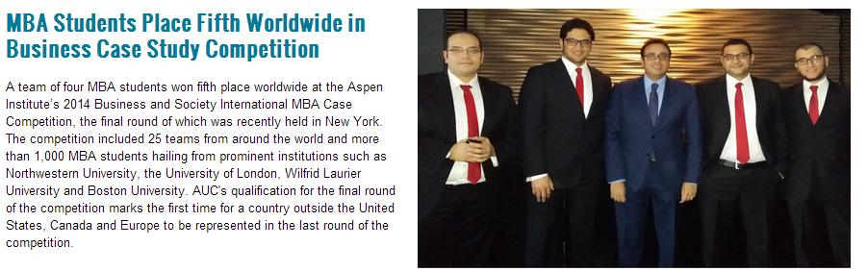](https://www.aucegypt.edu/news/stories/mba-students-place-fifth-worldwide-business-case-study-competition)Resume of  
**Mostafa Siraj**  
**Transformational Cyber Leader**

Mostafa.siraj@gmail.com

<http://www.linkedin.com/in/mostafasiraj>

Cell Phone: +44 73911 50891

Last Update: 15th Sept, 2020

Summary

Mostafa is a globally recognized senior cyber leader and [worldwide renowned speaker (AppSec US speaker)](https://appsecusa2015.sched.org/speaker/mostafa_siraj.1tssijvd) with more than 13 years of experience in the fields of application security, DevSecOps, penetration testing, vulnerability management, software development and leadership. Mostafa has a diverse cyber experience ranging from multinational corporations to consultation companies and vendors. Mostafa holds a master degree in business administration (MBA) from The American University in Cairo (Triple Crown Accredited) and a bachelor of Computer Engineering from Cairo University. Mostafa is currently the Head of UK Vulnerability Management and Application Security at Capital One and is based in London, UK.

What do my previous managers say about me

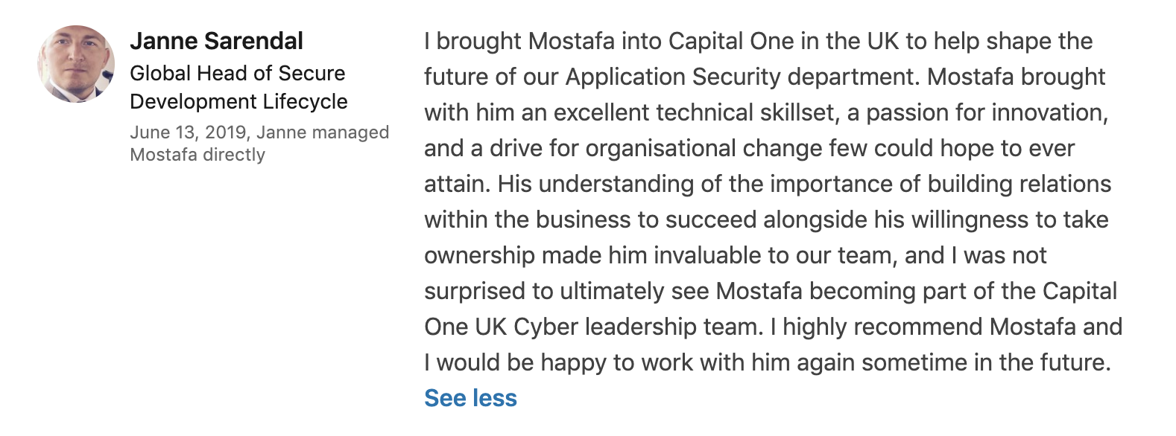

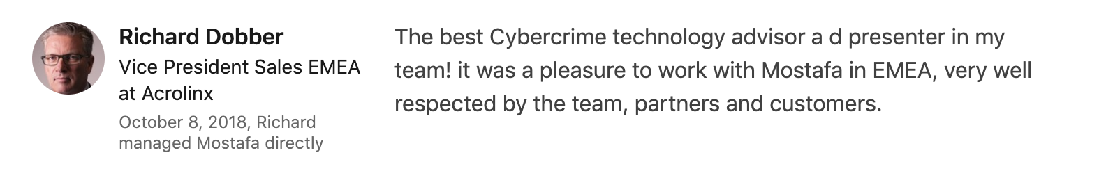

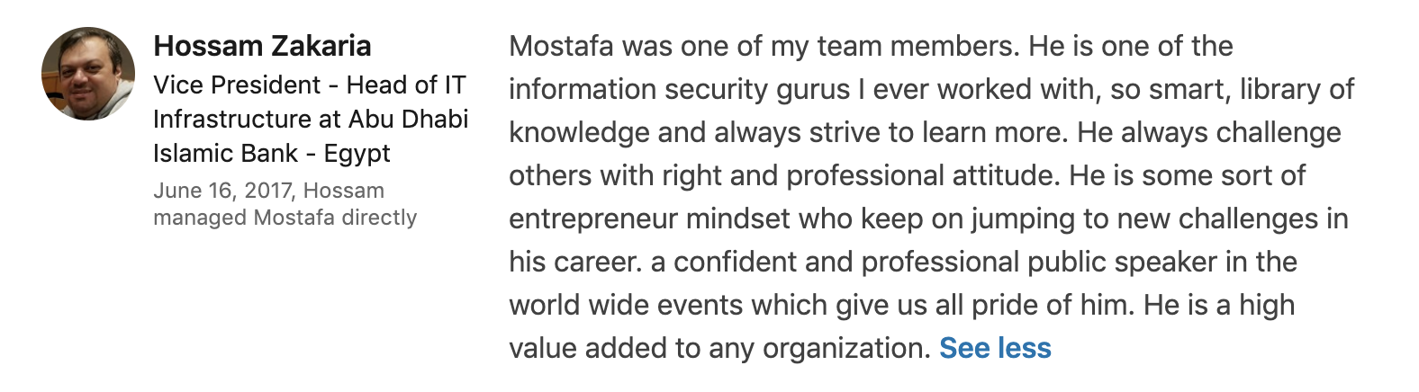

[For more references, kindly check the recommendations section in my LinkedIn](https://www.linkedin.com/in/mostafasiraj/)

Professional Experience

**Capital One** (Feb 2018 – Current)

*Senior Manager: Head of UK Vulnerability Management and Application Security (promotion) – March 2020 – Current*

* Member of the Cyber Leadership Team managing all aspects of the Cyber org such as resourcing, budget and overall strategy).
* Leading the penetration testing team and ensuring that the UK adheres to the penetration tests requirements and leading the way across lines of businesses in adopting latest technologies and achieving targets.
* Leading the vulnerability management team responsible of all of the UK on-prem and cloud infrastructure assets including servers, containers, endpoints and IoT. Driving remediation based on business risk and Enterprise policies.
* Leading the DevSecOps team responsible of supporting secure development practices such as static code analysis and software composition analysis.
* Leading an engineering team responsible of engineering ProductX: a fast, responsive and developer focused security scanning tool that works locally and in pipelines. The engineering team is also responsible of building an automated reporting capability for developers to support them in remediation.
* Leading the security education and evangelism steering group responsible of all security educational programs such as the security champions program, the Cyber curriculum academy and the phishing program.

*Head of UK Application Security Team (promotion) – Oct 2018 – Feb 2020*

* Leading the Security Assessments, DevSecOps and AppSec Governance teams (based in London and Nottingham).
* Acting as a global contributor in shaping the strategy and the evolution of AppSec and DevSecOps across Capital One Enterprise.
* DevSecOps: Managing the engineering of ProductX a fast, responsive and developer focused application security tool that works locally and in pipelines.
* Governance: Major automation and delegation exercise that saved the team 60% of their time.

*Senior AppSec Engineer (Manager Level) – Feb 2018 – Oct 2018*

* Main responsibility to shift the team’s security activities left.
* Deputy Manager for the AppSec team in the UK (the team is based in London and Nottingham).
* Initiated the Security Champions program within Capital One.
* Initiated the security initiatives project (security champions integrating security controls into the pipeline -DevOps to DevSecOps):
* Introducing the Secure Design Patterns library and adding security controls to existing Design Patterns.

**Whitehat Security** (Jan 2016 – Nov 2017)

*Senior Security Advisor – EMEA (based in Dubai & London)*

* The face of Whitehat in EMEA, representing WH in all events and acts as the main speaker for all the AppSec talks in EMEA (Blackhat Europe, InfoSec London, Excel, IP Expo and many other security conferences).
* Advising security controls and processes to improve the security posture of WH’s major clients in EMEA.
* Designing application security programs for EMEA clients and supporting them execute it.
* Managing PoCs for Whitehat prospects (web vulnerability assessments, source code analysis and mobile security assessments).
* Managing the pre/post sales activities in the EMEA region.
* Managing 3 distributers and more than 20 partners by technically enabling them, helping them in RFPs and helping them manage their prospects and existing client.

**Help AG** (Feb 2015 – Dec 2016)

*Senior Security Analyst - GCC (based in Doha)*

* Leading the penetration testing team in Qatar (4 members running over 80 projects).
* Managing the pre/post sales activities in the GCC region.
* Performing vulnerability assessment and penetration testing services for mobile, web and infrastructure (more than 20 different projects for government, banking, healthcare, retail and other sectors in the GCC region).
* Performing Software architecture review, source code review and software assurance maturity audits.

**Etisalat Egypt** (Aug 2010 – Oct 2014)

*Senior Security Specialist (based in Cairo)*

* Managing the secure SDLC program for more than 200 projects across the company.
* Setting security requirements, reviewing architecture, performing source code analysis, performing penetration testing for existing and new web apps and mobile apps (average 6 per month)
* Responding to security/hacking incidences by identifying the root cause and the source of the incidence and reevaluate the security measures to stop future attacks.
* Gave more than 40 hours of application security training for the development and quality teams.
* Sponsored and managed unifying the identity management across Etisalat users using Oracle Identity Management (5 years project).

**ITWorx** (Aug 2008 – Aug 2010)

*Research Engineer (based in Cairo)*

* Defining and managing the application security program for all teams across the company.
* Performing architecture review, source code review, and vulnerability assessment for more than 50 projects.
* Working in different research projects such as building pilots at all cloud service providers at the time (AWS, Microsoft Azure, Google AppEngine).
* Developing mobile apps (iOS and Android) and SharePoint sites.

Education

**Master of Business Administration (double concentration) (2012 - 2014)**

The American University in Cairo (AUC)

Double concentration in International Business and Leadership & Human Resources Management

**GPA: 3.92**

[**Ranked 5th worldwide in the Aspen Case Competition**](https://www.aucegypt.edu/news/stories/mba-students-place-fifth-worldwide-business-case-study-competition) among 25 top schools worldwide (Including Boston, New York, London and Wilfrid University)

**Founder & ex-President of the Business Graduate Association**: The association is responsible of increasing engagement and providing services to the Business School graduate students at AUC (Budget of 500K EGP per year)

Graduate student representative & financial coordinator for all the leadership conferences that the university sponsored 2012-2014: [ASGA](http://www.asgaonline.com/ME2/Default.asp) Washington, US in October 2012, [APCA](http://www.apca.com/index.php) Syracuse, US in October 2013 and [NCSL](http://www.ncslcollege.com/) Virginia, US in April 2014

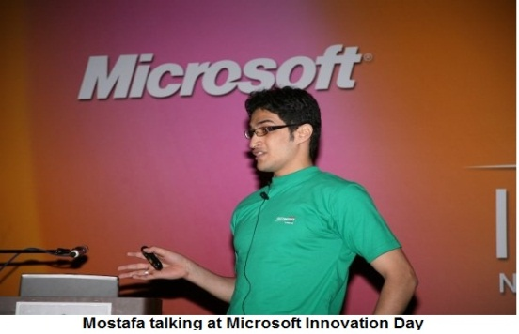**Bachelor of Engineering (Honors) (2003 – 2008)**

Computer Engineering Department, Faculty of Engineering, Cairo University

Major: Software Engineering

**Degree: Very Good With Honor**

Graduation Project: Automated Customer Service

Project Category: Arabic Natural Language Processing (NLP), Machine Learning, Artificial Intelligence and Transliteration

**Graduation Project Degree: Excellent**

Sponsors: [Yamli](http://www.yamli.com/ar/)

Description: We built a text based chatterbot that understands questions and provides answers in Arabic Natural Language (using bayesian networks). The chatterbot was able to learn new questions while chatting with customers. The chatterbot was able to transliterate English letters to Arabic words.

**Accomplishments: I was invited to Google Zurich to demonstrate my graduation project and become a possible Googler.**

Extracurricular Activities

* [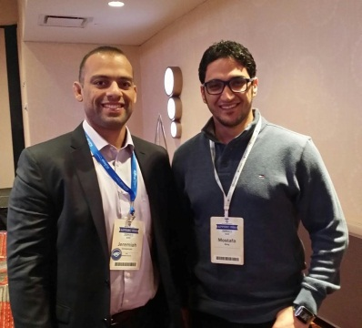](https://twitter.com/jeremiahg/status/403323268129501185)[Public speaker](http://vimeo.com/user2372806) in technical events, my talks usually are about “Application Security” (Events: IP Expo UK, InfoSec, Code Camps, Microsoft Innovation Day and others)
* The founder and ex-president of the Business Graduate Association on AUC. The Association represents all the graduate business students on AUC and offers a lot of services to enrich the students’ experience at AUC.
* Cofounder of OWASP Cairo Chapter, OWASP Qatar Chapter
* More than **30,000** views of my presentations on [SlideShare](http://www.slideshare.net/MostafaSiraj)